**Overview**

**Simple App Feature**:

1. List Customers
2. Add a new Customers
3. Update a Customers
4. Delete a Customers

**Customer List Demo**:

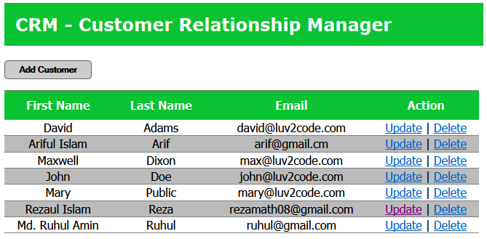

**How Spring-MVC App Work**:

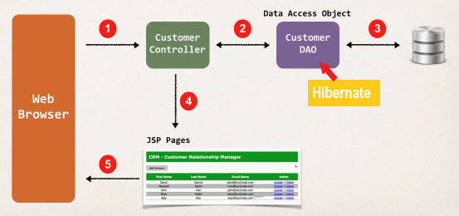

**Working Process**:

1. Browser make a request to Customer-Controller
2. Customer Controller make use of Data-Access-Object (DAO).
3. This data access object will actually access the database for us, using the Hibernate API.
4. Then we’ll get the data back from the database and controller will place that into our Spring-MVC model.
5. And then send that over to the JSP pages
6. Finally, the JSP pages will render that data to the browser

**Customer Data Access Object (DAO)**:

* Responsible for interfacing with the database
* This is a common design pattern: **Data-Access-Object (DAO)**
* Helper class or utility class for talking to the database

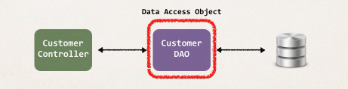

**Customer Data Access Object Methods**:

1. saveCustomer(…)
2. getCustomers(…)
3. getCustomer(…)
4. updateCustomer(…)
5. deleteCustomer(…)

Overview